
Foundation University Islamabad
School of Science and Technology

Name: Hunaina Yasir Roll Number: 073
Subject: Programming Fundamentals Lab Section: B
LAB # 5
Tasks:
5.1 ‘for’ Statement

Write a C++ program that takes an integer input from the user, prints all even integers less than or equal to this number and greater than or equal to 0, calculates the sum of these even, and displays results on the screen. Your program should have the following interface.
Enter a number: 7
Even numbers less than or equal to 7 are: 2 4 6
Sum of even numbers: 12

Source code:
#include <iostream>
using namespace std;
int main() {
int num;
int sum=0;
cout<<"Enter a Number : ";
cin>>num;
cout << "Even number less than or equal to "<<num<<" are : ";
for (int i =1; i <= num; i++) {
if(i%2 == 0) { //it will check if its even number or not
cout<<i<<"\t";
sum += i;
}
}
cout<< "\n sum of even numbers = " <<sum;
}
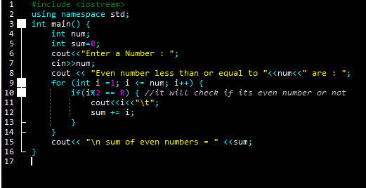

Output:
Enter a Number : 7
Even number less than or equal to 7 are : 2 4 6
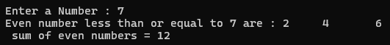
sum of even numbers = 12

5.2 ‘while’ Statement
Repeat Task. 5.1 using while loop.
Source code:

#include <iostream>
using namespace std;
int main() {
int num;
int sum=0;
cout<<"Enter a Number : ";
cin>>num;
cout << "Even number less than or equal to "<<num<<" are : ";
int i = 1;
while (i<=num) {
if(i%2 == 0) { //it will check if its even number or not
cout<<i<<"\t";
sum += i;
}
i++;
}
cout<< "\n sum of even numbers = " <<sum;
}
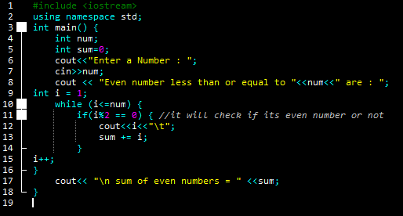

Output:
Enter a Number : 6
Even number less than or equal to 6 are : 2 4 6
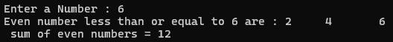
sum of even numbers = 12

5.3 Write a C++ program that takes an integer input from the user in the variable named ‘num’, calculates the sum of all integers from 1 to ‘num’, and displays this sum on screen. Your program should have the following interface.
Enter any value: 10
Sum of integers from 1 to 10 is: 55

Hint:
for (int i =1; i <= num; i++) {
sum += i;
}

Source code:
#include <iostream>
using namespace std;

int main() {
cout << "Hunaina Yasir" << endl;
cout << "Roll number: 073" << endl;

int num;
int sum = 0;

cout << "Enter any value: ";
cin >> num;

for (int i = 1; i <= num; i++) {
sum += i;
}

cout << "Sum of integers from 1 to " << num << " is: " << sum << endl;

return 0;
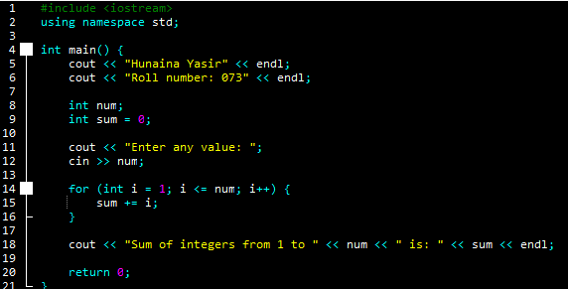
}

Output:
Hunaina Yasir
Roll number: 073
Enter any value: 8
Sum of integers from 1 to 8 is: 36
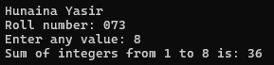
5.4 Write a program to calculate the factorial of number input by user using both for and while loops.
Enter a positive integer: 5
The Factorial of 5 is: 120

Hint: Factorial of 5 = 5 * 4* 3 *2 * 1 = 120
factorial *= i;

Source code:
#include <iostream>
using namespace std;

int main() {
cout << "Hunaina Yasir" << endl;
cout << "Roll number: 073" << endl;

int num;
int factorial = 1;

cout << "Enter a positive integer: ";
cin >> num;

for (int i = 1; i <= num; i++) {
factorial *= i;
}

cout << "The Factorial of " << num << " is: " << factorial << endl;

factorial = 1;
int i = 1;

while (i <= num) {
factorial *= i;
i++;
}

cout << "The Factorial of " << num << " is: " << factorial << endl;

return 0;
}

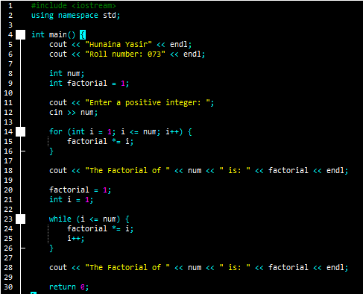
Output:
Hunaina Yasir
Roll number: 073
Enter a positive integer: 1
The Factorial of 1 is: 1
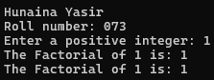
The Factorial of 1 is: 1

5.5 Show the output of the following code.

#include <iostream>
using namespace std;

int main() {
int N;
int sum = 0;
cout << "Enter a positive integer N: ";
cin >> N;
if (N <= 0) {
cout << "Invalid input. Please enter a positive integer." << endl; return 1; // Exit with an error code.
}
cout << "Sum of even numbers from 1 to " << N << ":" << endl;
for (int i = 2; i <= N; i += 2) {
sum += i;
cout << i;
if (i < N - 1 && i + 2 <= N) {
cout << " + ";
} else if (i == N) {
cout << " = " << sum;
}
}
}
Output:
Enter a positive integer N: 9
Sum of even numbers from 1 to 9:
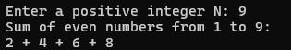
2 + 4 + 6 + 8
5.6 Show the output of the following code.

#include <iostream>
using namespace std;

int main() {
int N;
cout << "Enter a number to generate a multiplication table: "; cin >> N;
cout << "Multiplication table for " << N << ":" << endl;
for (int i = 1; i <= 10; ++i) {
cout << N << " x " << i << " = " << N * i;
if (i != 10) {
cout << endl; // Print a newline for all lines except the last one.
}
}
cout << endl; // Print an extra newline for spacing.
return 0;
}
Output:
Enter a number to generate a multiplication table: 8
Multiplication table for 8:
8 x 1 = 8
8 x 2 = 16
8 x 3 = 24
8 x 4 = 32
8 x 5 = 40
8 x 6 = 48
8 x 7 = 56
8 x 8 = 64
8 x 9 = 72
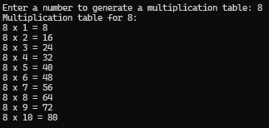
8 x 10 = 80

5.7 Show the output of the following code.

#include <iostream>
using namespace std;

int main(){
int N;
int sum = 0;
cout << "Enter a positive integer N: ";
cin >> N;
cout << "Sum of prime numbers from 1 to " << N << ":" << endl;
for (int i = 2; i <= N; ++i) {
bool isPrime = true;
for (int j = 2; j * j <= i; ++j) {
if (i % j == 0) {
isPrime = false;
break;
}
}
if (isPrime) {
sum += i;
cout << i;
if (i < N) {
cout << " + ";
}
}
}
cout << " = " << sum << endl;
}
Output:
Enter a positive integer N: 5
Sum of prime numbers from 1 to 5:
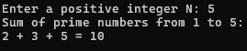
2 + 3 + 5 = 10

5.8 Show the output of the following code.

#include <iostream>
using namespace std;

int main() {
char c;
bool isLowercaseVowel, isUppercaseVowel;
cout << "Enter an alphabet: ";
cin >> c;
// evaluates to true if c is a lowercase vowel
isLowercaseVowel = (c == 'a' || c == 'e' || c == 'i' || c == 'o' || c == 'u');
// evaluates to true if c is an uppercase vowel
isUppercaseVowel = (c == 'A' || c == 'E' || c == 'I' || c == 'O' || c == 'U');
if (!isalpha(c)) {
cout << "Error! Non-alphabetic character." << endl;
} else if (isLowercaseVowel || isUppercaseVowel) {
cout << c << " is a vowel." << endl;
} else {
cout << c << " is a consonant." << endl;
}
}
Output:
Enter an alphabet: H
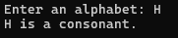
H is a consonant.

5.9 Show the output of the following code.

#include <iostream>
using namespace std;

int main() {
int startValue;
cout << "Enter the starting value for the countdown: ";
cin >> startValue;
for (int i = startValue; i >= 0; i--) {
cout << "Countdown: " << i << endl;
}
}

Output:
Enter the starting value for the countdown: 9
Countdown: 9
Countdown: 8
Countdown: 7
Countdown: 6
Countdown: 5
Countdown: 4
Countdown: 3
Countdown: 2
Countdown: 1
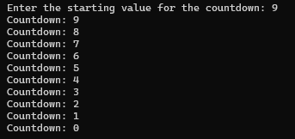
Countdown: 0
Exercises:
5.1 Repeat Task 5.1 using ‘do/while’ statements.

Source code:
#include <iostream>
using namespace std;

int main() {
cout << "Hunaina Yasir" << endl;
cout << "Roll number: 073" << endl;

int num;
int sum = 0;
int i = 0;

cout << "Enter a number: ";
cin >> num;

cout << "Even numbers less than or equal to " << num << " are: ";

do {
if (i != 0 && i % 2 == 0) {
cout << i << " ";
sum += i;
}
i++;
} while (i <= num);

cout << endl;
cout << "Sum of even numbers: " << sum << endl;

return 0;
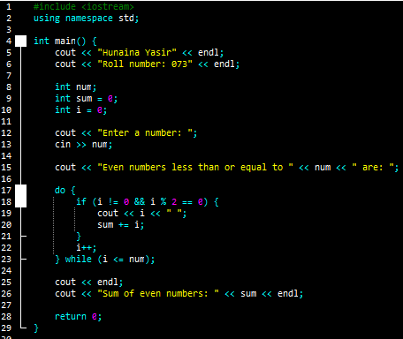
}

Output:
Hunaina Yasir
Roll number: 073
Enter a number: 4
Even numbers less than or equal to 4 are: 2 4
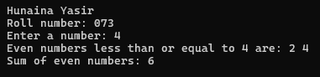
Sum of even numbers: 6

5.2 Develop a C++ program that calculates and displays the factorial of a positive integer using a for loop with decrement. Prompt the user for an integer and then calculate its factorial. Explain the decrement logic in your comments.

Source code:
#include <iostream>
using namespace std;

int main() {
cout << "Hunaina Yasir" << endl;
cout << "Roll number: 073" << endl;

int num;
long long factorial = 1;

cout << "Enter a positive integer: ";
cin >> num;

for (int i = num; i >= 1; i--) {
factorial *= i;
}

cout << "The Factorial of " << num << " is: " << factorial << endl;

return 0;
}
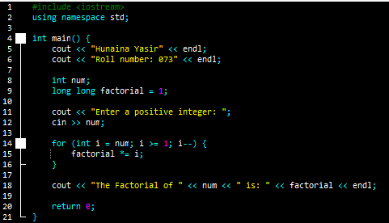
Output:
Hunaina Yasir
Roll number: 073
Enter a positive integer: 9
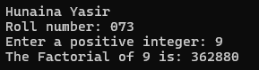
The Factorial of 9 is: 362880
5.3 Develop a C++ program that calculates and displays the sum of all even numbers from 100 down to 1 using a for loop with decrement. Explain the loop's decrement logic in your comments.

Source code:
#include <iostream>
using namespace std;

int main() {
cout << "Hunaina Yasir" << endl;
cout << "Roll number: 073" << endl;

int sum = 0;

for (int i = 100; i >= 1; i--) {
if (i % 2 == 0) {
sum += i;
}
}

cout << "Sum of all even numbers from 100 to 1 is: " << sum << endl;

return 0;
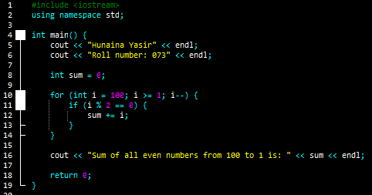
}

Output:
Hunaina Yasir
Roll number: 073
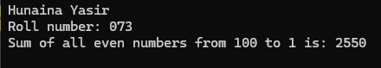
Sum of all even numbers from 100 to 1 is: 2550
5.4 Write a C++ program that prompts the user for their age and keeps asking until they enter a valid age (between 1 and 120). Use a do-while loop to validate the input.

Source code:
#include <iostream>
using namespace std;

int main() {
cout << "Hunaina Yasir" << endl;
cout << "Roll number: 073" << endl;

int age;

do {
cout << "Enter your age: ";
cin >> age;
} while (age < 1 || age > 120);

cout << "Your age is: " << age << endl;

return 0;
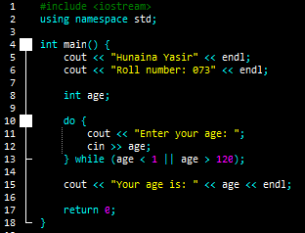
}
Output:
Hunaina Yasir
Roll number: 073
Enter your age: 19
Your age is: 19
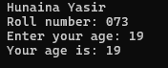
5.5 Write a C++ program to simulate a simple ATM machine. The program should allow the user to deposit or withdraw funds and display the balance. Use a while loop and switch statement to repeatedly provide options until the user chooses to exit. Explain the loop's menu-driven logic in your comments.

Source code:
#include <iostream>
using namespace std;

int main() {
cout << "Hunaina Yasir" << endl;
cout << "Roll number: 073" << endl;

double balance = 0;
int choice;

// The while loop runs indefinitely until the user chooses to exit
while (true) {
cout << "\nATM Menu:" << endl;
cout << "1. Deposit" << endl;
cout << "2. Withdraw" << endl;
cout << "3. Check Balance" << endl;
cout << "4. Exit" << endl;
cout << "Enter your choice: ";
cin >> choice;

// Switch statement handles the user's menu choice
switch (choice) {
case 1: {
double amount;
cout << "Enter amount to deposit: ";
cin >> amount;
balance += amount;
cout << "Amount deposited successfully." << endl;
break;
}
case 2: {
double amount;
cout << "Enter amount to withdraw: ";
cin >> amount;
if (amount <= balance) {
balance -= amount;
cout << "Amount withdrawn successfully." << endl;
} else {
cout << "Insufficient balance." << endl;
}
break;
}
case 3:
cout << "Current balance: " << balance << endl;
break;
case 4:
cout << "Thank you for using ATM." << endl;
return 0; // Exit the program
default:
cout << "Invalid choice, try again." << endl;
}
}

return 0;
}
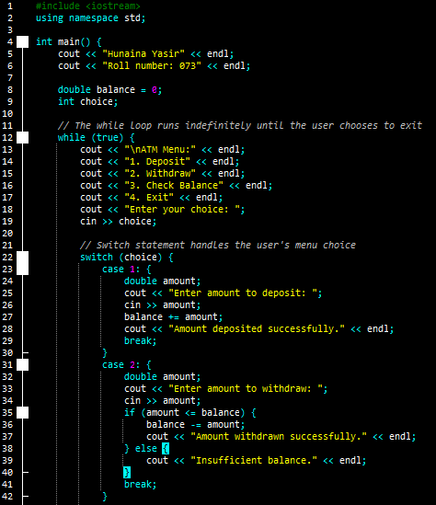

Output:
Hunaina Yasir
Roll number: 073

ATM Menu:
1. Deposit
2. Withdraw
3. Check Balance
4. Exit
Enter your choice: 2
Enter amount to withdraw: 10
Insufficient balance.

ATM Menu:
1. Deposit
2. Withdraw
3. Check Balance
4. Exit
Enter your choice: 4
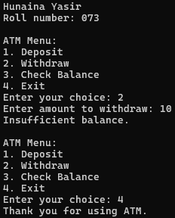
Thank you for using ATM.
